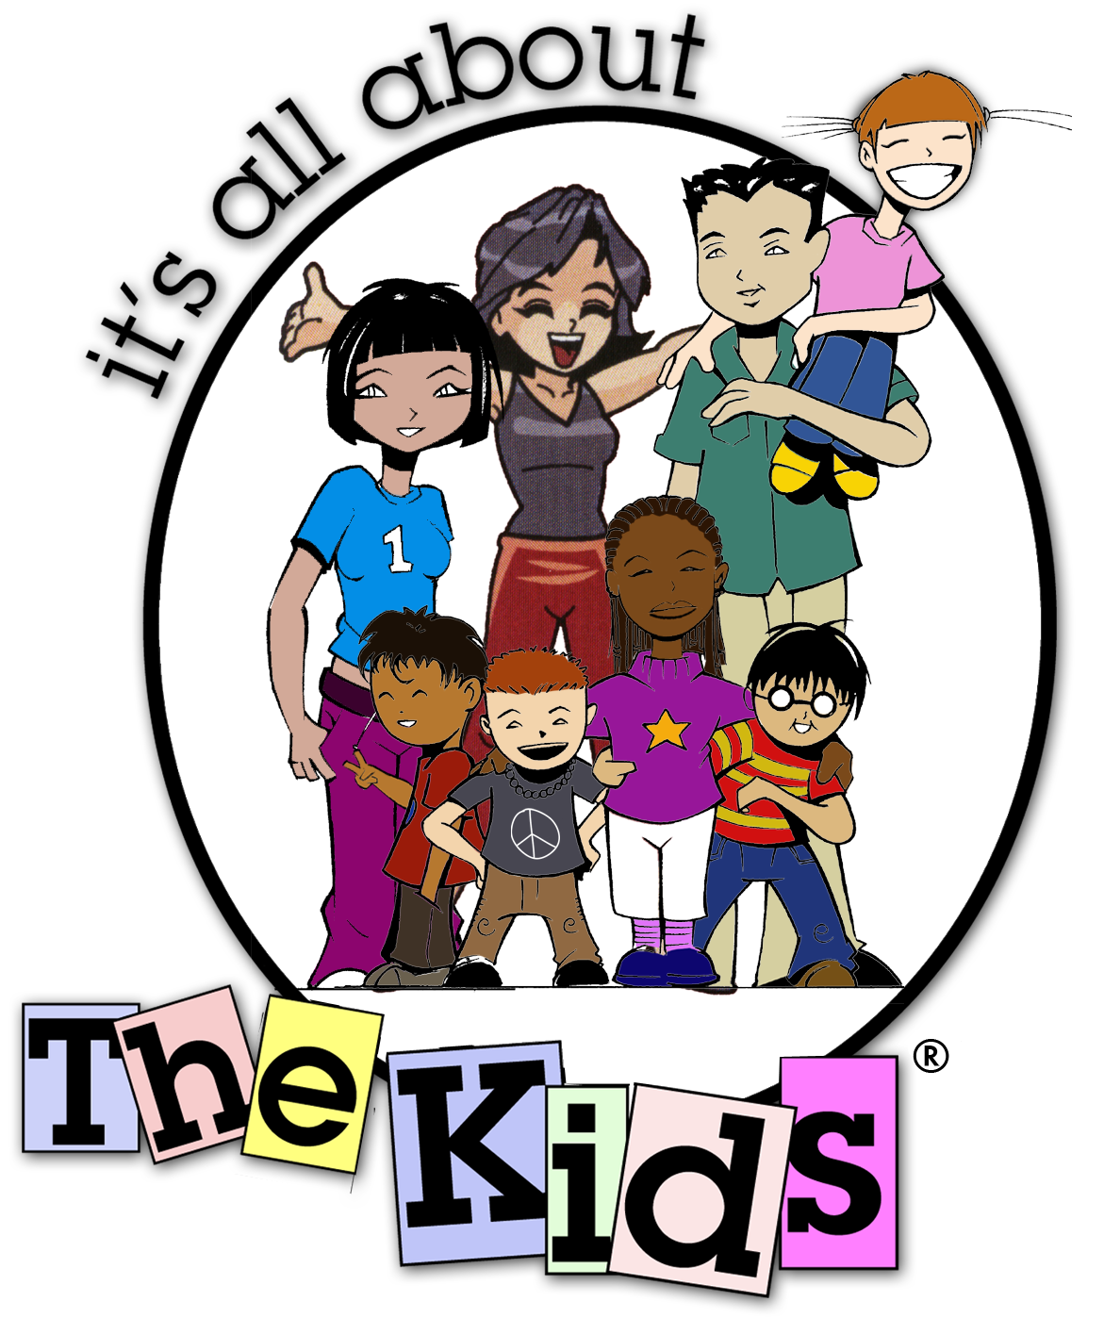

<field 1>

Dear < field m > ,

It’s All About the Kids® Foundation is a 501 c[3] non profit organization that creates and provides new and innovative programs to benefit children’s charities and enhances the lives of less fortunate children. We help kids SUCCEED! We help over 1500 children that are impacted by HIV/AIDS, homelessness, neglect, abuse and crime in Southern California and Baja Mexico.

Thank you so much for your generous donation of purchasing < field d > at the auction at the < field b > . With your donation, we will continue our programs and activities that make a difference in children’s lives. We are so grateful for your kindness!

We hope that you will continue to be a part of our adventure. Please visit www.ItsAllAboutTheKids.org for upcoming events and programs.

Only the best,
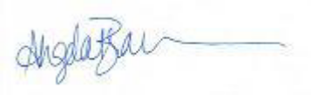

Angela Brannon
President of the Board
It’s All About the Kids® Foundation
www.ItsAllAboutTheKids.org

It’s All About the Kids® is a 501c[3] non profit organization.
EIN; Tax Id #20-1114086.

